**Soham Bhattacharya(116cs0171), Computer Networks Lab**

**Experiment**

1.     Get the following details of your own system:

-         IP Address

-         MAC Address

-         Subnet address

-         Gateway address

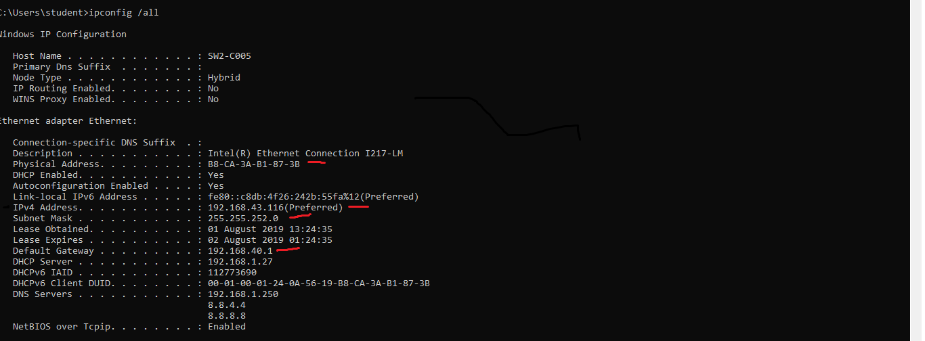

2.     Change your IP address at its 1st, 2nd, 3rd and 4th subfields (once at a time) and note down your observation.

* Changing the 4th subfield of the IP address still grants access to the LAN but access to the WAN is also disabled. (The IP address is Preferred)
* Changing the 3rd subfield of the IP address causes the LAN to appear as unidentified. (The IP address is Preferred)
* Changing the 2nd subfield of the IP address causes the LAN to appear as unidentified. (The IP address is Preferred)
* Changing the 4th subfield of the IP address causes the LAN to appear as unidentified. (The IP address is displayed as Tentative).

3.     Change the MAC address.

It is not possible to change the MAC address as it is hardcoded by the manufacture of the network interface card.

4.     Ping to your gateway and note down the response.

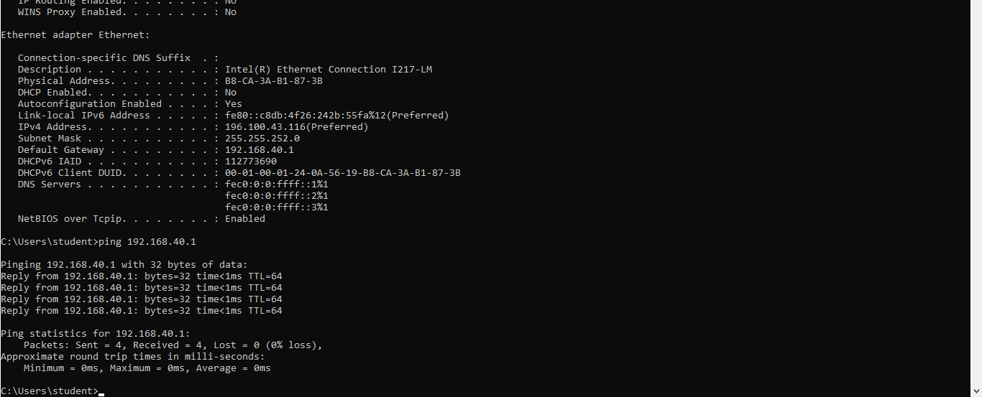

5. Design a client server program and analyse its operation and performance. Study the port addresses used and the socket programming too.

A client server program was created in simplex and duplex configuration using python sockets.

6.     Change the port address and note down the result.

If the port address of the server/client is only changed then they will not be able to communicate with each other. If both the port of client/server is changed to the same port they are able to communicate effectively.

7.     Test the network connectivity of your system by the loop back address.

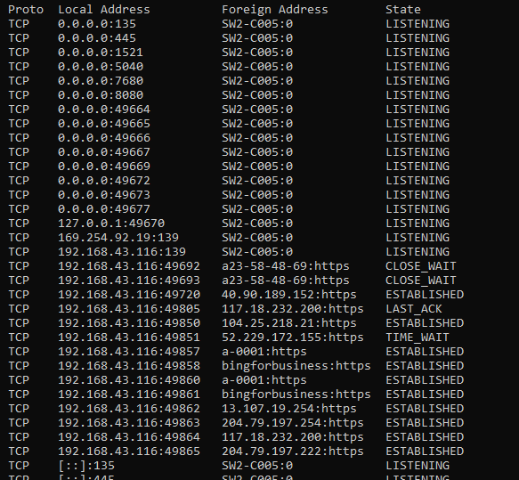

8.     Find the BW of your network

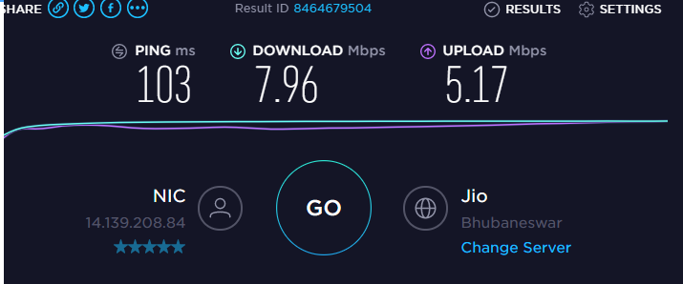

Submitted by,

Soham Bhattacharya

116cs0171